PROJEKT Załącznik nr 3b do uchwały nr /14
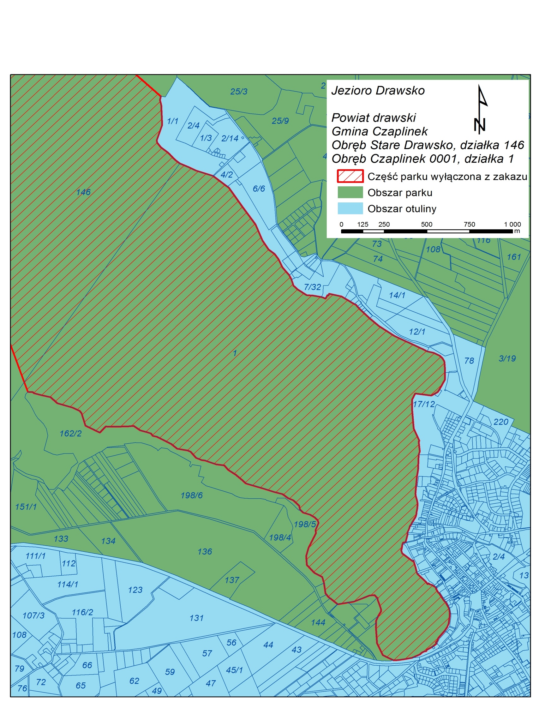
Sejmiku Województwa Zachodniopomorskiego
z dnia 2014 r.

Określenie części Drawskiego Parku Krajobrazowego: obszaru Jeziora Drawsko na którym obowiązuje wskazane w § 4 ust. 6 uchwały odstępstwo od zakazu używania łodzi motorowych i innego sprzętu motorowego

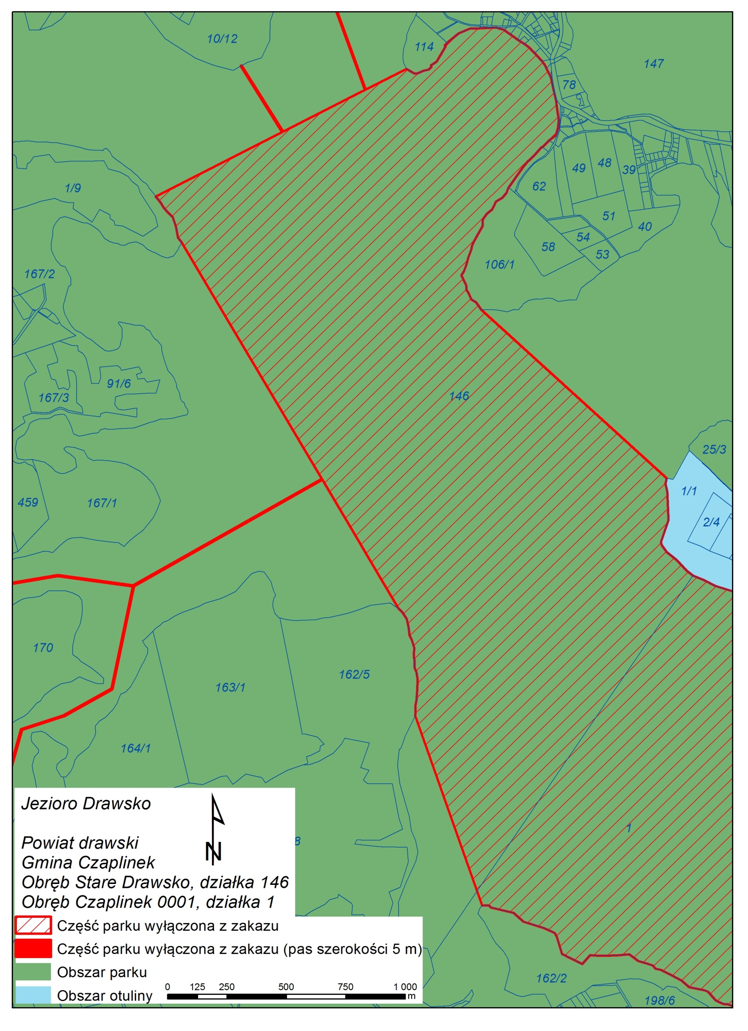
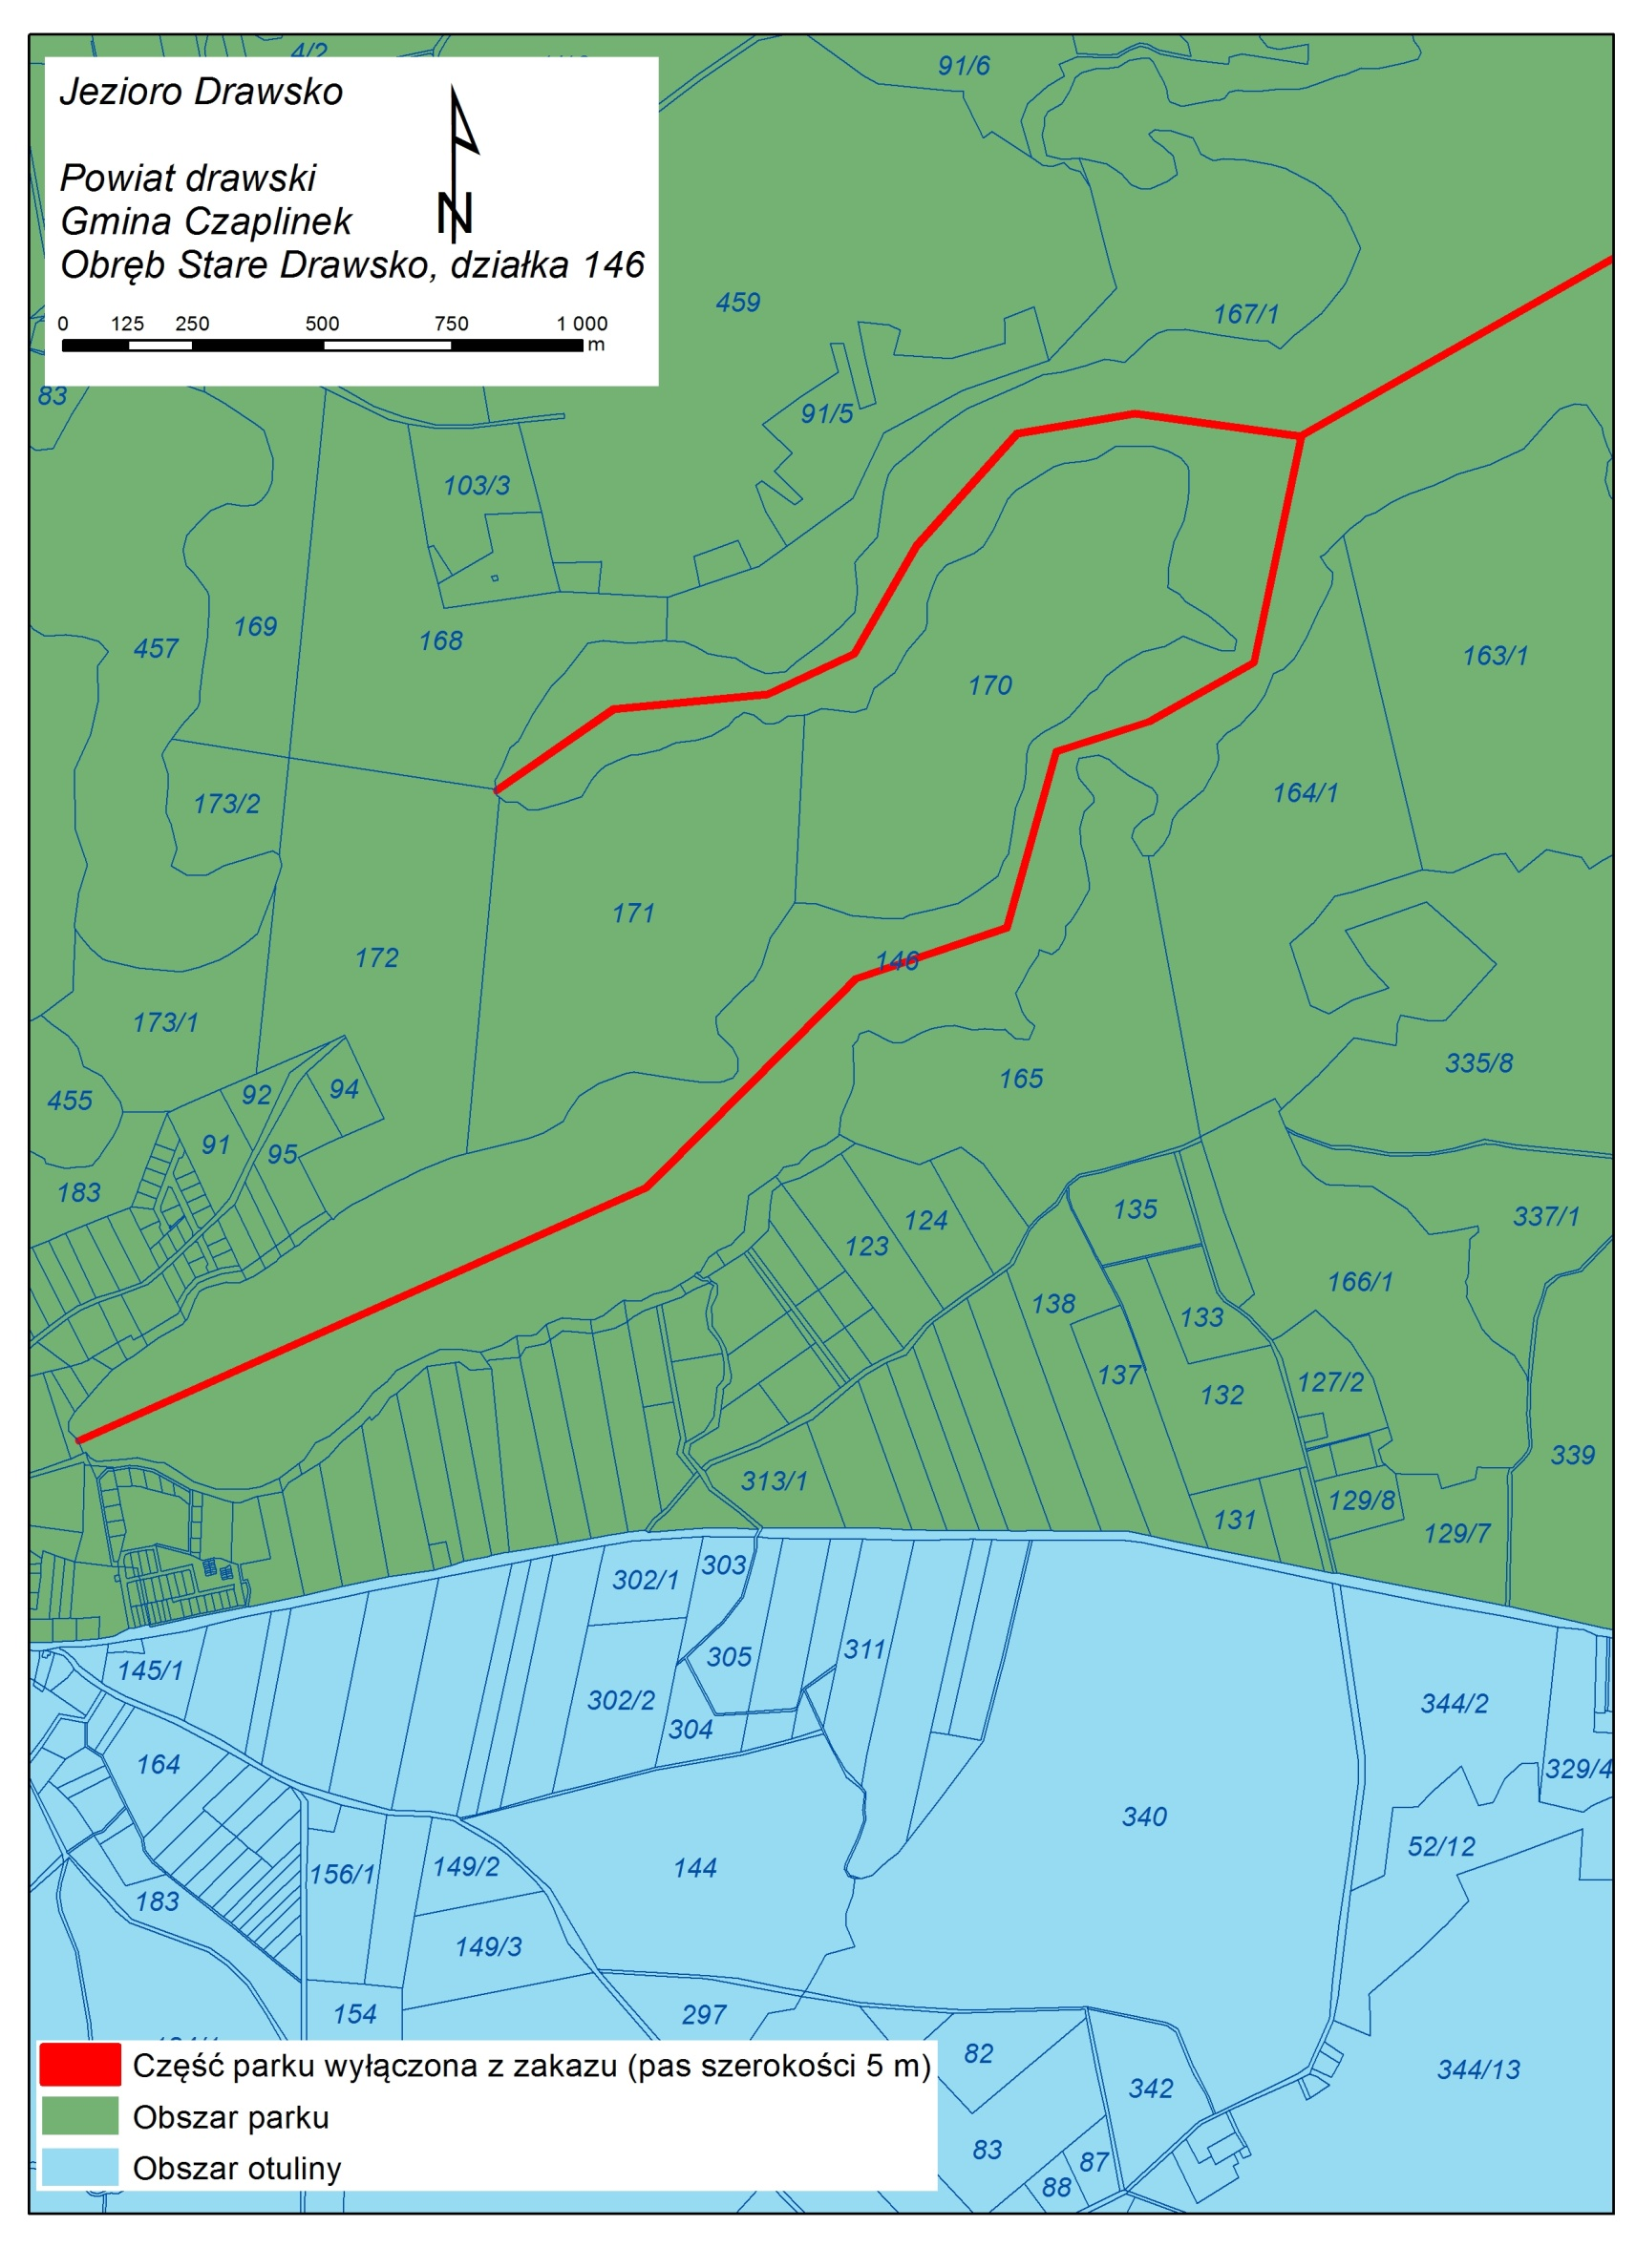
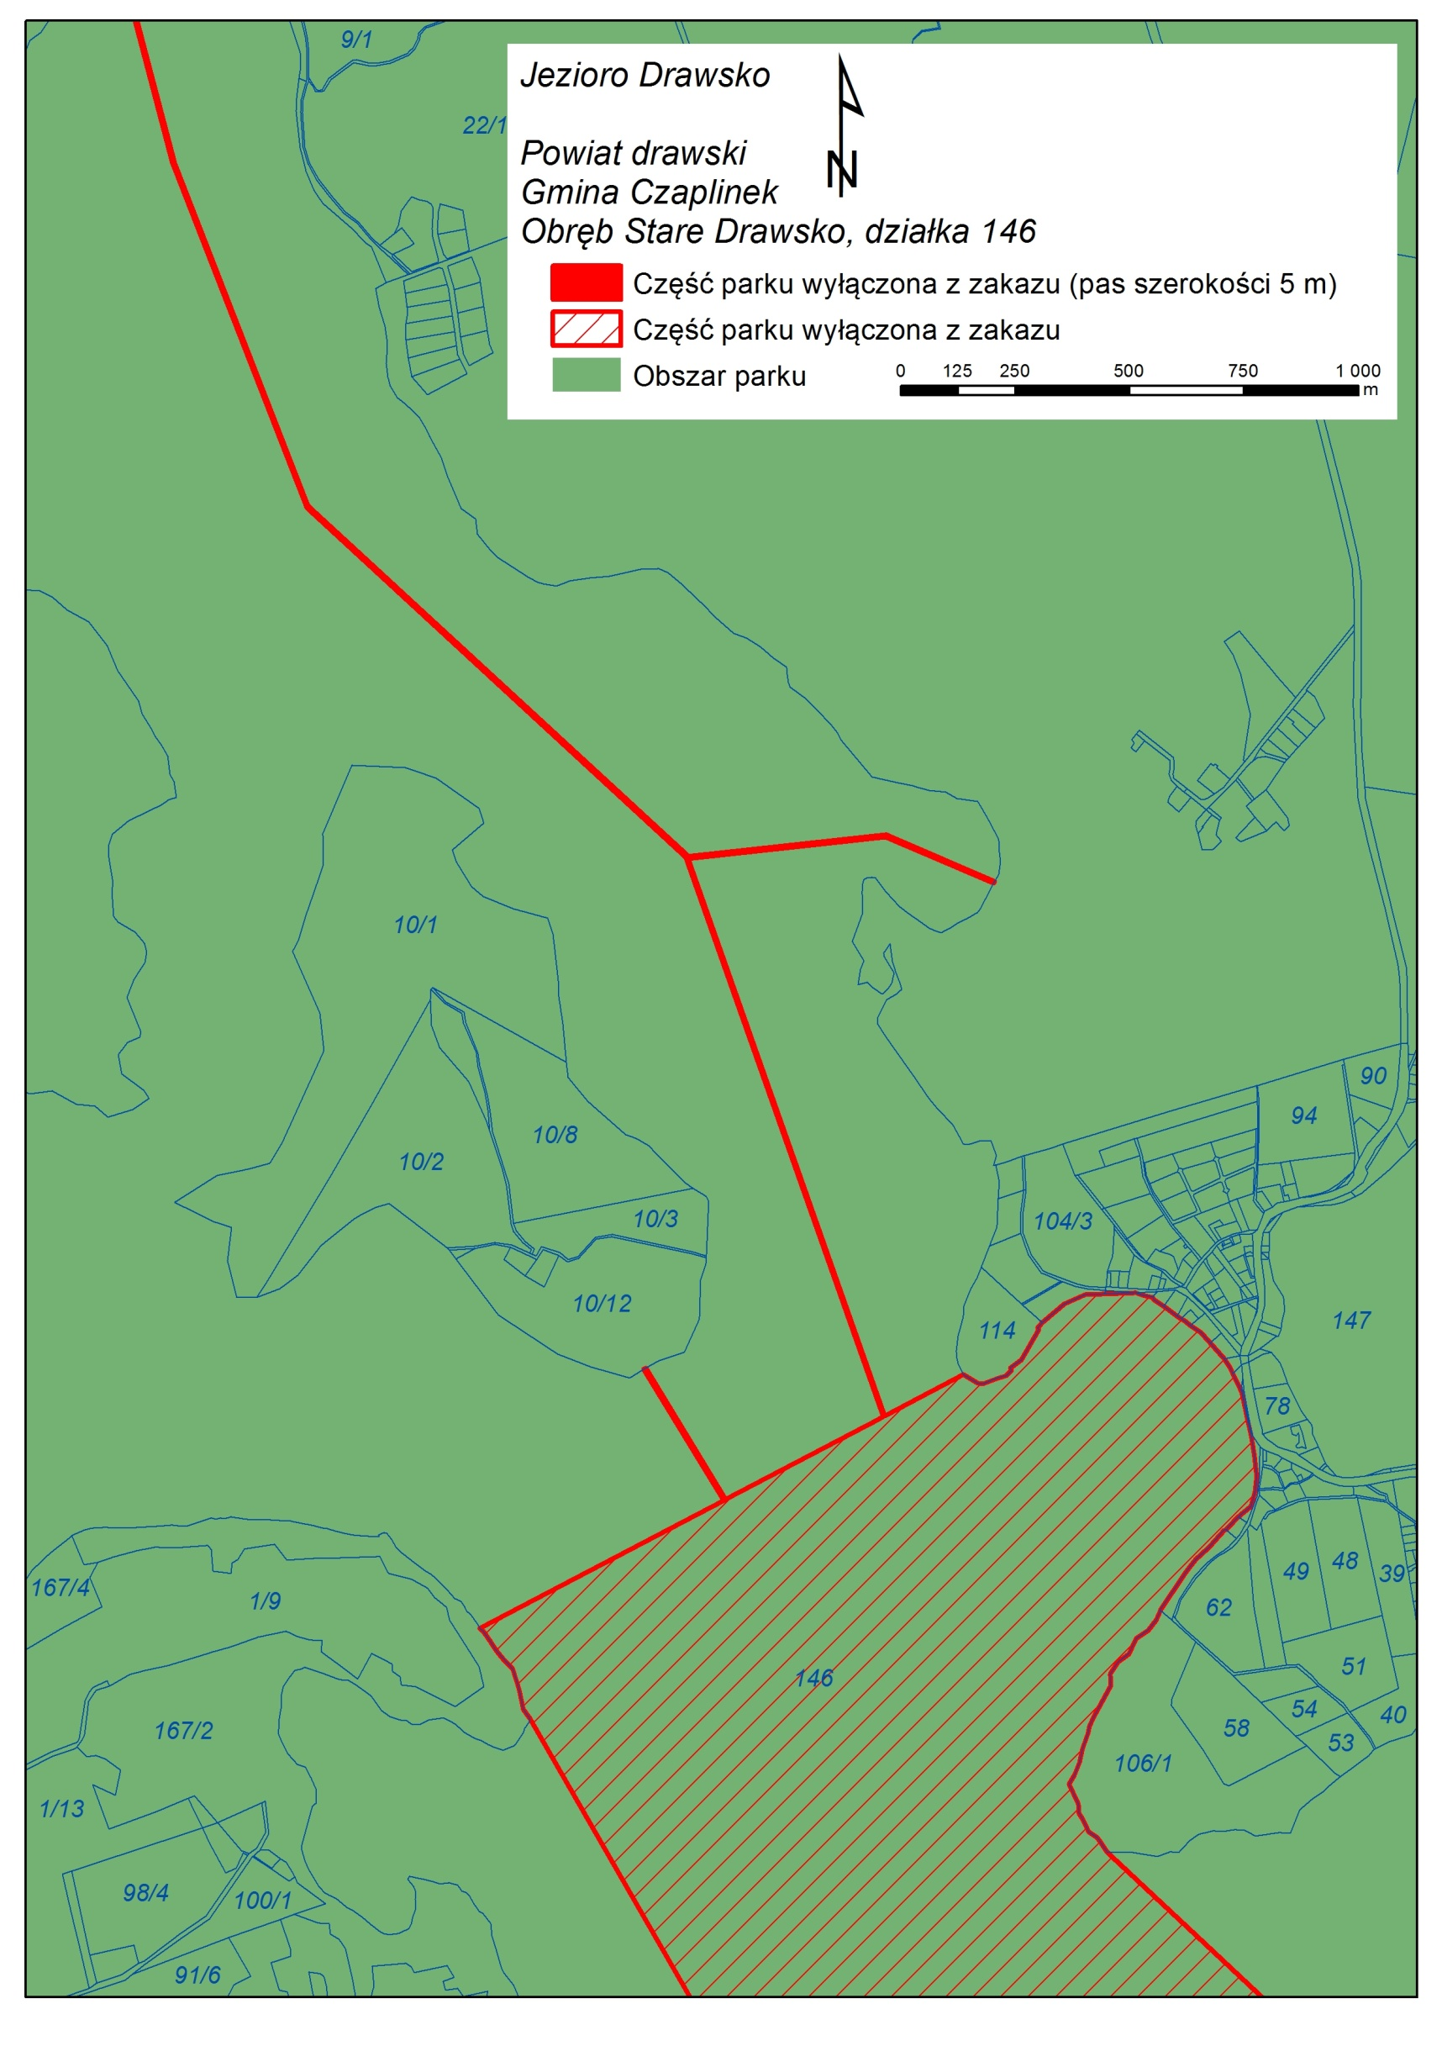
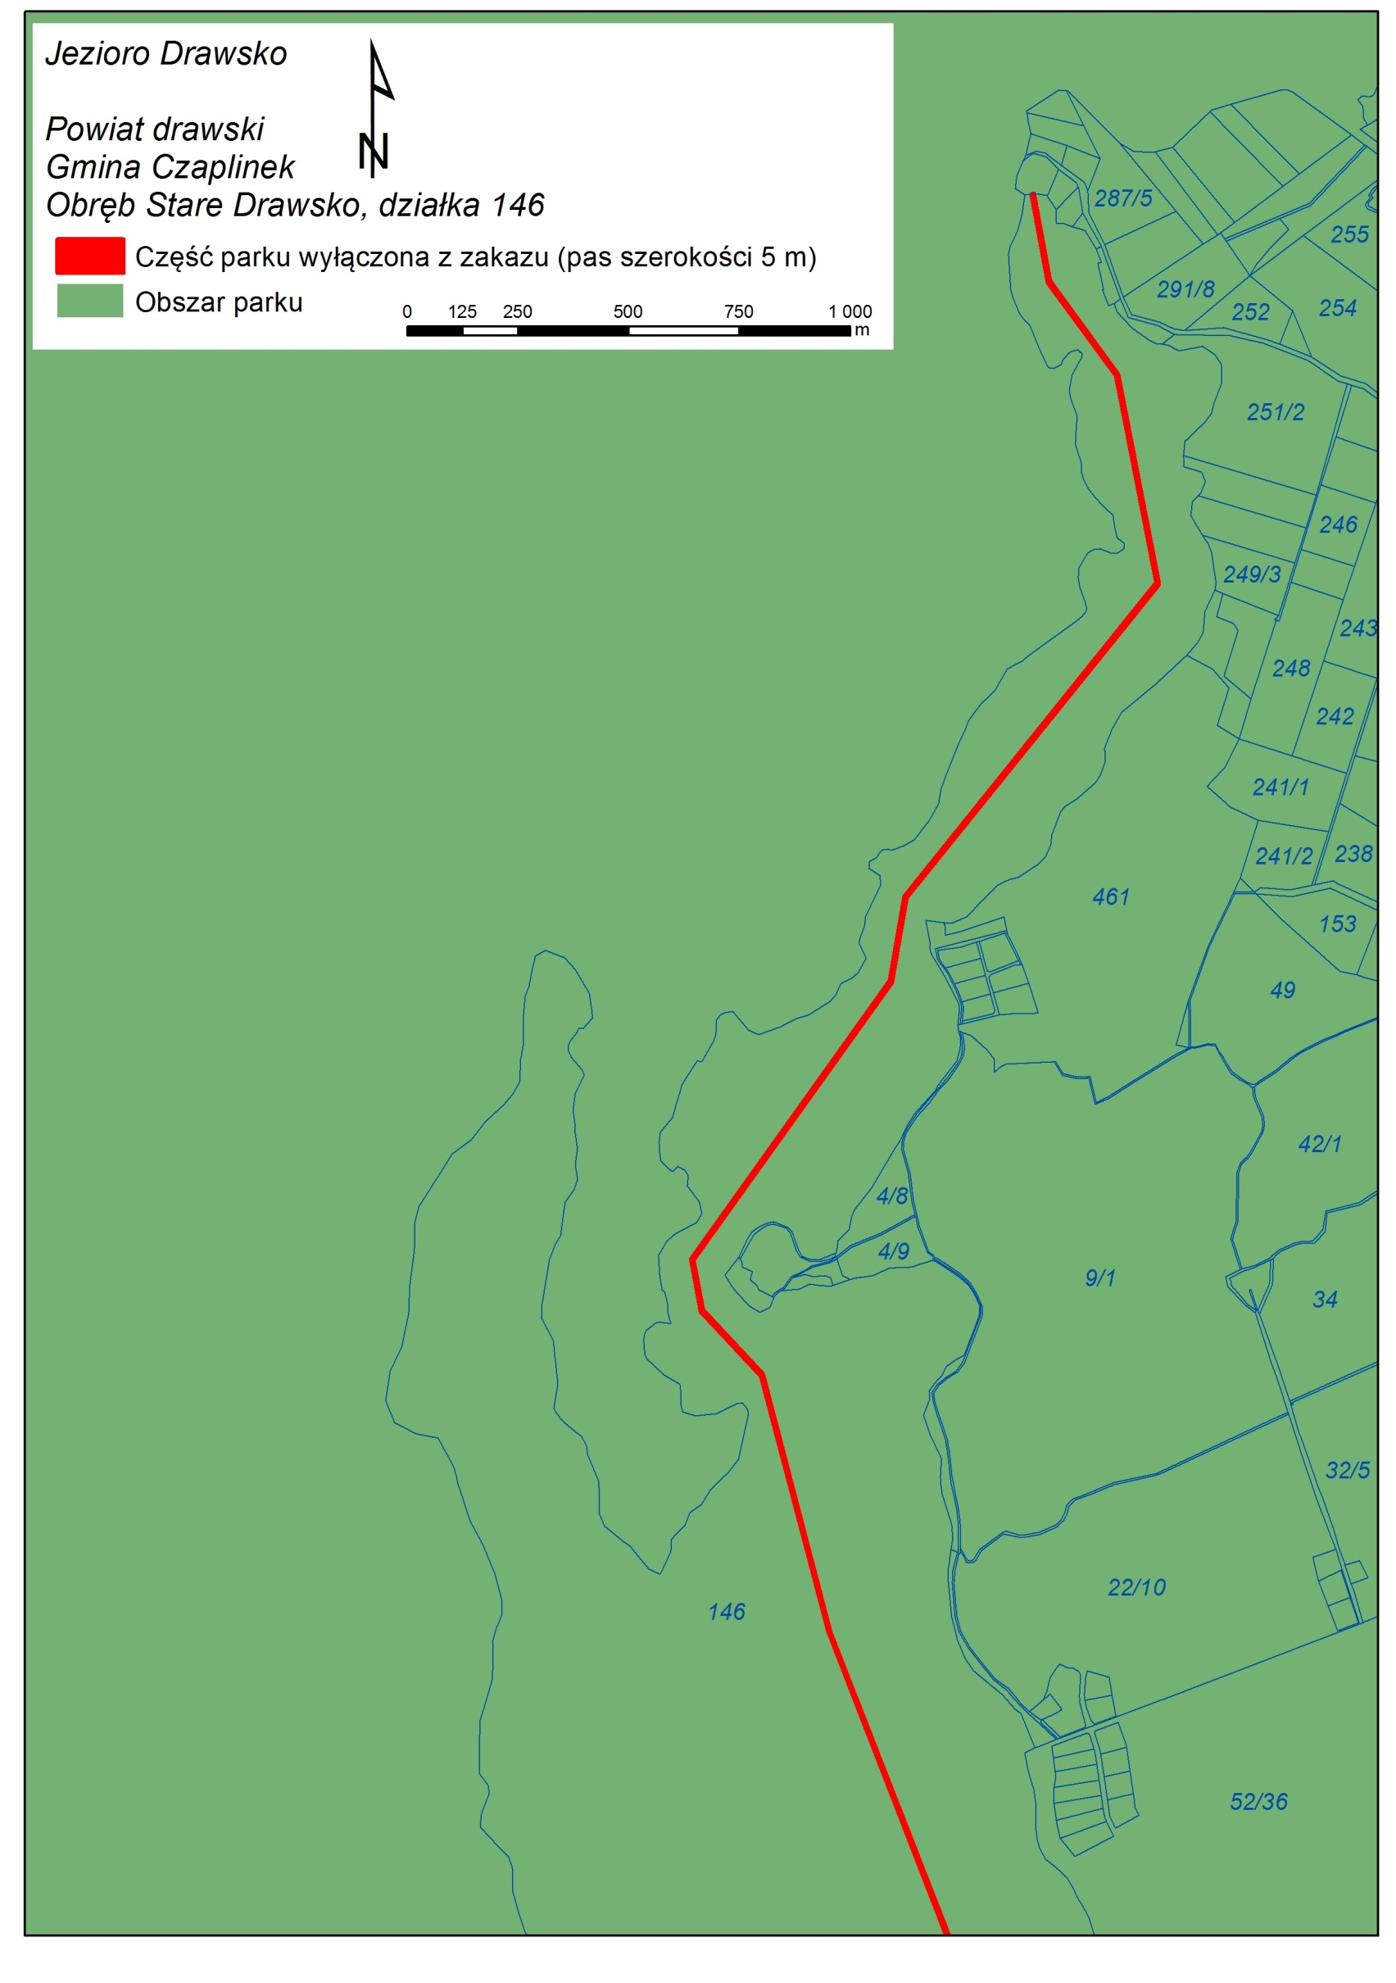

Wykaz współrzędnych punktów załamania obszaru jeziora Drawsko wyłączonego z zakazu
(układ współrzędnych PL – 1992)

Nr | X | Y | Nr | X | Y
1 | 313853,49137 | 641069,7533 | 46 | 314257,28920 | 640512,5471
2 | 313884,79060 | 641050,1490 | 47 | 314231,43380 | 640495,7881
3 | 313896,89470 | 641049,2277 | 48 | 314214,84449 | 640461,8359
4 | 313926,24400 | 641061,5245 | 49 | 314191,41549 | 640442,9978
5 | 313947,69720 | 641066,9562 | 50 | 314174,77612 | 640418,3005
6 | 313959,21829 | 641078,4538 | 51 | 314175,25178 | 640392,0495
7 | 313956,15849 | 641084,2232 | 52 | 314138,53310 | 640325,1153
8 | 313980,46310 | 641101,3599 | 53 | 314129,45263 | 640304,1382
9 | 314018,55608 | 641167,0852 | 54 | 314126,50291 | 640289,7952
10 | 314015,35751 | 641171,1002 | 55 | 314113,71513 | 640254,3575
11 | 314025,47870 | 641182,2760 | 56 | 314106,83600 | 640225,1659
12 | 314073,63010 | 641223,0035 | 57 | 314096,29494 | 640196,3806
13 | 314120,40190 | 641243,4820 | 58 | 314084,19910 | 640177,3354
14 | 314161,47180 | 641245,1964 | 59 | 314104,62039 | 640134,7024
15 | 314230,41290 | 641248,0662 | 60 | 314106,23460 | 640114,8058
16 | 314244,72430 | 641242,7751 | 61 | 314115,21325 | 640100,5127
17 | 314266,77090 | 641238,1101 | 62 | 314126,97364 | 640073,7270
18 | 314269,85700 | 641232,6296 | 63 | 314146,96898 | 640061,0771
19 | 314292,01100 | 641218,3060 | 64 | 314168,64810 | 640028,8771
20 | 314320,53580 | 641196,3746 | 65 | 314949,40212 | 639300,3247
21 | 314329,23220 | 641190,9488 | 66 | 314944,45507 | 639276,4616
22 | 314336,70030 | 641186,2931 | 67 | 314952,56463 | 639244,4044
23 | 314350,16080 | 641176,7343 | 68 | 314957,35267 | 639120,0139
24 | 314372,29480 | 641160,8098 | 69 | 314925,45802 | 639024,9022
25 | 314381,29460 | 641150,8110 | 70 | 314928,96884 | 639011,3074
26 | 314393,05410 | 641137,8934 | 71 | 314950,26347 | 638981,8829
27 | 314424,08740 | 641103,7752 | 72 | 314992,26966 | 638948,2694
28 | 314436,41020 | 641085,3888 | 73 | 315033,38606 | 638902,2198
29 | 314442,96160 | 641071,2022 | 74 | 315060,31077 | 638880,4991
30 | 314461,67780 | 641032,2598 | 75 | 315106,47080 | 638861,1105
31 | 314474,73760 | 640971,4467 | 76 | 315154,73470 | 638836,3777
32 | 314483,25650 | 640932,7877 | 77 | 315253,15480 | 638803,8464
33 | 314489,26160 | 640891,8069 | 78 | 315257,81090 | 638800,6504
34 | 314494,53430 | 640847,2426 | 79 | 315339,25570 | 638736,9027
35 | 314490,93650 | 640814,2619 | 80 | 315347,58030 | 638730,3866
36 | 314482,68230 | 640782,3441 | 81 | 315430,89010 | 638603,8513
37 | 314453,98430 | 640760,0876 | 82 | 315503,86090 | 638500,5498
38 | 314426,92290 | 640731,5010 | 83 | 315544,25060 | 638399,2098
39 | 314423,10450 | 640731,0850 | 84 | 315580,70400 | 638343,2395
40 | 314390,95680 | 640693,9630 | 85 | 315615,06570 | 638316,3141
41 | 314361,50270 | 640666,6324 | 86 | 315638,45110 | 638282,5772
42 | 314342,57070 | 640642,4747 | 87 | 315661,38470 | 638231,9134
43 | 314283,89704 | 640556,9199 | 88 | 315700,93370 | 638183,8096
44 | 314280,81718 | 640549,1629 | 89 | 315713,33520 | 638158,4502
45 | 314275,13610 | 640534,5030 | 90 | 315713,85960 | 638156,7291

Nr | X | Y | Nr | X | Y
91 | 315725,85130 | 638117,5042 | 140 | 316455,54650 | 637003,4404
92 | 315750,03250 | 638095,0672 | 141 | 316455,27890 | 636990,8395
93 | 315802,27730 | 638059,5963 | 142 | 316454,35890 | 636968,0608
94 | 315840,02490 | 638056,3717 | 143 | 316448,28340 | 636928,9525
95 | 315889,37560 | 638048,1199 | 144 | 316442,16950 | 636869,8896
96 | 315899,83230 | 638044,4468 | 145 | 316439,39080 | 636822,2846
97 | 315913,50070 | 638037,8803 | 146 | 316440,03510 | 636809,7022
98 | 315923,77480 | 638059,2510 | 147 | 316447,77710 | 636779,6487
99 | 315929,04920 | 638056,7109 | 148 | 316448,95670 | 636774,0953
100 | 315934,48140 | 638067,8701 | 149 | 316449,71922 | 636767,5340
101 | 316005,81430 | 638051,3024 | 150 | 316450,94960 | 636756,4704
102 | 316025,51140 | 638038,8902 | 151 | 316451,65730 | 636750,3630
103 | 316055,95500 | 638019,7058 | 152 | 316449,83050 | 636738,3601
104 | 316065,47940 | 638013,6913 | 153 | 316448,58540 | 636723,6912
105 | 316082,79570 | 638003,8068 | 154 | 316447,98110 | 636718,3091
106 | 316090,17810 | 637999,5867 | 155 | 316445,62750 | 636705,8143
107 | 316098,82650 | 637989,5680 | 156 | 316444,64550 | 636697,7892
108 | 316109,12710 | 637977,5938 | 157 | 316441,58910 | 636681,1796
109 | 316110,63040 | 637975,8485 | 158 | 316437,78030 | 636672,4010
110 | 316122,19240 | 637964,2128 | 159 | 316421,25280 | 636643,9738
111 | 316134,36990 | 637951,9417 | 160 | 316416,23610 | 636633,4619
112 | 316171,63940 | 637914,4105 | 161 | 316414,30860 | 636628,7441
113 | 316224,26400 | 637867,5446 | 162 | 316412,99460 | 636628,1672
114 | 316317,18970 | 637803,7313 | 163 | 316405,98850 | 636616,6458
115 | 316481,45880 | 637722,3102 | 164 | 316402,07700 | 636602,2870
116 | 316507,90070 | 637708,9490 | 165 | 316391,89070 | 636578,3891
117 | 316544,59240 | 637699,7653 | 166 | 316393,01290 | 636567,7016
118 | 316578,60940 | 637683,4435 | 167 | 316380,94420 | 636519,0367
119 | 316595,16850 | 637667,7429 | 168 | 316376,13320 | 636517,7052
120 | 316607,48530 | 637646,2136 | 169 | 316366,78150 | 636515,2172
121 | 316610,48920 | 637617,3688 | 170 | 316362,72480 | 636505,2222
122 | 316611,20060 | 637575,9045 | 171 | 316356,89120 | 636470,9256
123 | 316611,20060 | 637575,8999 | 172 | 316354,95450 | 636470,4809
124 | 316611,59630 | 637533,6536 | 173 | 316356,98620 | 636461,3980
125 | 316579,65860 | 637472,7935 | 174 | 316360,93680 | 636448,3193
126 | 316578,28020 | 637470,1887 | 175 | 316423,00321 | 636399,4706
127 | 316568,53190 | 637454,0542 | 176 | 316427,60020 | 636404,1292
128 | 316552,15110 | 637444,8013 | 177 | 316437,21950 | 636367,2004
129 | 316531,03340 | 637432,8629 | 178 | 316439,57540 | 636358,1768
130 | 316437,12050 | 637445,2943 | 179 | 316446,85540 | 636330,2319
131 | 316419,14700 | 637409,1473 | 180 | 316450,59950 | 636320,7796
132 | 316419,26510 | 637338,6098 | 181 | 316500,40300 | 636271,6292
133 | 316428,04350 | 637227,2834 | 182 | 316509,54900 | 636256,7464
134 | 316461,23130 | 637150,4802 | 183 | 316514,77090 | 636262,3697
135 | 316458,15040 | 637145,6984 | 184 | 316522,82900 | 636255,1793
136 | 316463,94470 | 637083,6920 | 185 | 316535,44390 | 636251,9662
137 | 316458,05930 | 637064,4789 | 186 | 316544,39100 | 636244,9444
138 | 316456,44530 | 637040,7880 | 187 | 316555,38620 | 636238,0180
139 | 316456,41340 | 637018,3209 | 188 | 316558,49980 | 636236,0504
189 | 316561,81910 | 636232,2195 | 240 | 315903,77520 | 636262,7450
190 | 316557,94200 | 636228,9721 | 241 | 315893,36140 | 636301,1995
191 | 316573,25540 | 636201,6277 | 242 | 315848,01790 | 636326,9292
192 | 316575,89010 | 636202,5407 | 243 | 315804,01530 | 636376,5045
193 | 316596,97590 | 636166,3702 | 244 | 315799,66530 | 636431,9804
194 | 316605,49222 | 636154,5367 | 245 | 315813,52960 | 636483,9088
195 | 316614,05380 | 636144,7532 | 246 | 315856,57360 | 636573,7974
196 | 316636,05340 | 636105,2470 | 247 | 315854,03970 | 636593,1948
197 | 316638,78848 | 636089,7835 | 248 | 315872,02060 | 636638,0228
198 | 316639,42350 | 636060,8738 | 249 | 315866,98840 | 636654,8372
199 | 316633,03880 | 636010,5044 | 250 | 315850,18520 | 636672,6138
200 | 316624,06140 | 635988,7002 | 251 | 315823,27590 | 636689,6271
201 | 316610,52580 | 635966,2719 | 252 | 315782,14300 | 636702,9846
202 | 316572,36930 | 635919,8602 | 253 | 315772,02880 | 636713,6464
203 | 316566,75660 | 635903,7195 | 254 | 315763,33200 | 636722,8066
204 | 316557,94570 | 635893,2208 | 255 | 315759,35180 | 636744,4381
205 | 316563,09410 | 635887,5543 | 256 | 315726,60160 | 636778,6617
206 | 316563,08960 | 635887,5504 | 257 | 315694,82700 | 636792,6644
207 | 316537,43652 | 635865,9274 | 258 | 315661,14850 | 636817,8585
208 | 316519,57110 | 635854,6662 | 259 | 315610,43860 | 636832,0249
209 | 316505,32680 | 635845,8348 | 260 | 315545,38140 | 636854,2275
210 | 316501,98160 | 635839,4043 | 261 | 315448,46590 | 636884,6701
211 | 316488,44360 | 635836,3708 | 262 | 315422,92630 | 636908,2350
212 | 316475,80580 | 635829,0410 | 263 | 315388,49640 | 636938,4078
213 | 316466,06940 | 635818,6444 | 264 | 315343,73570 | 636969,8726
214 | 316418,02430 | 635796,6843 | 265 | 315320,94210 | 636997,2182
215 | 316372,78840 | 635788,5342 | 266 | 315273,53560 | 637003,3587
216 | 316337,86380 | 635782,4877 | 267 | 315208,32880 | 637028,2433
217 | 316308,80870 | 635782,1491 | 268 | 315188,84440 | 637030,0400
218 | 316247,97410 | 635813,7560 | 269 | 315156,35870 | 637044,7537
219 | 316213,67860 | 635887,9876 | 270 | 315123,94650 | 637082,6732
220 | 316208,18960 | 635988,7131 | 271 | 315107,46800 | 637089,6678
221 | 316208,26960 | 636015,2654 | 272 | 315045,27800 | 637101,7865
222 | 316208,30590 | 636029,0911 | 273 | 315011,47530 | 637131,1832
223 | 316221,12420 | 636058,8596 | 274 | 314964,49180 | 637156,0643
224 | 316237,94380 | 636087,2764 | 275 | 314925,36520 | 637176,9691
225 | 316237,33550 | 636103,0261 | 276 | 314902,98990 | 637181,8421
226 | 316218,37520 | 636158,8328 | 277 | 314891,63260 | 637196,2187
227 | 316217,27790 | 636169,7686 | 278 | 314864,33740 | 637205,1233
228 | 316214,01770 | 636171,2636 | 279 | 314829,93440 | 637215,4790
229 | 316200,58380 | 636187,5290 | 280 | 314791,71900 | 637244,0425
230 | 316170,03890 | 636185,4718 | 281 | 314750,10660 | 637240,1547
231 | 316134,45690 | 636169,8700 | 282 | 314726,78680 | 637239,2734
232 | 316079,70900 | 636148,0164 | 283 | 314669,85870 | 637238,1294
233 | 316043,02180 | 636141,6085 | 284 | 314627,05500 | 637239,9458
234 | 315983,89370 | 636131,4260 | 285 | 314593,63270 | 637201,8636
235 | 315983,07690 | 636132,3932 | 286 | 314508,70490 | 637245,5304
236 | 315940,20930 | 636167,7863 | 287 | 314486,35780 | 637321,9450
237 | 315927,95910 | 636177,8572 | 288 | 314476,70700 | 637336,5760
238 | 315919,08790 | 636190,6820 | 289 | 314433,33660 | 637357,8697
239 | 315913,52240 | 636198,7249 | 290 | 314345,78610 | 637384,9925
291 | 314304,55280 | 637423,0981 | 342 | 311677,65520 | 638326,5331
292 | 314251,17800 | 637435,8226 | 343 | 311676,00690 | 638326,0733
293 | 314209,17130 | 637446,6461 | 344 | 311378,82720 | 638296,2503
294 | 314200,31900 | 637454,8239 | 345 | 311152,45430 | 638135,7972
295 | 314172,33855 | 637455,2861 | 346 | 311151,54480 | 638141,2623
296 | 313890,77229 | 638274,0591 | 347 | 311377,01350 | 638301,0934
297 | 313891,34125 | 638321,5592 | 348 | 311675,50760 | 638331,0483
298 | 313895,48457 | 638341,2821 | 349 | 311840,54170 | 638409,5470
299 | 313897,40315 | 638376,4603 | 350 | 311960,33100 | 638621,1246
300 | 313900,61229 | 638430,3103 | 351 | 312154,50290 | 638842,7861
301 | 313896,04787 | 638462,5587 | 352 | 312383,64240 | 638882,3364
302 | 313888,07617 | 638481,7616 | 353 | 312701,51730 | 638837,7980
303 | 313887,76156 | 638511,2377 | 354 | 313496,30160 | 639298,0946
304 | 313885,16042 | 638526,0532 | 355 | 312904,66709 | 640321,6969
305 | 313884,29325 | 638542,3231 | 356 | 312891,20116 | 640340,2379
306 | 313886,29705 | 638566,7324 | 357 | 312882,54040 | 640382,4298
307 | 313874,72414 | 638605,2227 | 358 | 312877,43084 | 640400,7109
308 | 313866,49457 | 638621,9769 | 359 | 312868,81553 | 640427,8706
309 | 313861,94235 | 638654,9757 | 360 | 312842,39982 | 640455,2608
310 | 313854,67030 | 638692,3129 | 361 | 312830,14145 | 640471,0603
311 | 313836,39610 | 638720,9669 | 362 | 312819,10123 | 640488,9340
312 | 313819,33941 | 638739,5794 | 363 | 312803,09049 | 640510,6522
313 | 313498,80780 | 639293,7681 | 364 | 312796,43074 | 640517,5754
314 | 312706,25280 | 638834,6714 | 365 | 313329,27960 | 640795,6822
315 | 312705,49470 | 638832,2576 | 366 | 313154,53489 | 641081,6439
316 | 312614,92880 | 638390,8501 | 367 | 313158,71326 | 641083,9292
317 | 312612,51150 | 638387,5138 | 368 | 313333,70120 | 640797,9919
318 | 312410,56450 | 638272,1150 | 369 | 313677,59190 | 640977,6305
319 | 312409,65940 | 638271,7109 | 370 | 313245,78190 | 642196,2422
320 | 312233,26260 | 638213,1397 | 371 | 312417,47770 | 642957,4726
321 | 312139,27030 | 637870,2250 | 372 | 312124,35180 | 643706,9023
322 | 312136,07210 | 637866,8179 | 373 | 311972,48210 | 644281,9757
323 | 311846,53530 | 637767,3857 | 374 | 311836,92350 | 644427,0690
324 | 311444,02260 | 637358,0551 | 375 | 311815,17650 | 644543,7667
325 | 311442,52760 | 637357,0095 | 376 | 312263,84020 | 645168,5330
326 | 310347,14260 | 636858,7650 | 377 | 312296,31340 | 645358,2052
327 | 310347,05750 | 636858,7263 | 378 | 312865,93150 | 646062,3509
328 | 310345,08390 | 636863,3477 | 379 | 312773,65650 | 646528,9808
329 | 310345,16900 | 636863,3864 | 380 | 312620,69930 | 646737,8824
330 | 311440,45750 | 637361,5608 | 381 | 312583,45240 | 646935,9388
331 | 311843,79660 | 637771,7318 | 382 | 312588,45160 | 646936,6185
332 | 312134,44810 | 637871,5468 | 383 | 312625,40380 | 646739,9207
333 | 312229,14780 | 638217,0418 | 384 | 312777,69070 | 646531,9346
334 | 312408,08380 | 638276,4562 | 385 | 312778,56160 | 646529,9507
335 | 312610,03080 | 638391,8550 | 386 | 312870,83650 | 646063,3209
336 | 312700,51050 | 638832,8903 | 387 | 312869,81890 | 646059,2063
337 | 312383,72260 | 638877,2764 | 388 | 312301,02140 | 645356,0751
338 | 312157,09760 | 638838,1601 | 389 | 312268,76850 | 645167,6892
339 | 311964,42960 | 638618,2154 | 390 | 312267,90150 | 645165,6165
340 | 311844,89280 | 638407,0836 | 391 | 311820,48300 | 644542,5841
341 | 311842,68940 | 638405,0318 | 392 | 311841,57190 | 644429,4176
393 | 311976,13560 | 644285,3891
394 | 311977,31640 | 644283,2523
395 | 312129,11280 | 643708,4564
396 | 312421,71280 | 642960,3714
397 | 313249,09470 | 642200,1221
398 | 313250,42450 | 642198,1104
399 | 313682,71780 | 642244,6843
400 | 313685,20890 | 642244,3147
401 | 313922,15420 | 642143,6699
402 | 313922,26180 | 642143,6242
403 | 313919,78820 | 642139,1970
404 | 313919,68710 | 642139,2400
405 | 313683,25340 | 642239,7130
406 | 313252,14090 | 642193,2664
407 | 313682,06770 | 640979,9685

